Vintage 2022

By the end of the 2021 winter rains, the clay slopes of Paroa Bay were fully saturated (along with the pruners), an occurrence not seen for several seasons. Like the previous year, winter temperatures were mild and led to another mid-August bud-burst in the Chardonnay. Wet pruners morphed into stuck tractor operators as the conditions tested the will of the crew deep into spring (wettest October on record!).
The vines were enjoying the abundance of moisture in the soil and warm growing conditions, however flowering in the Chardonnay was poor. Given the tumultuous spring by the time the end of the year rolled around the vintage was delicately poised. December and January were more favorable, and things quickly started falling our way with some lucky rolls of the dice regarding canopy management and spraying.

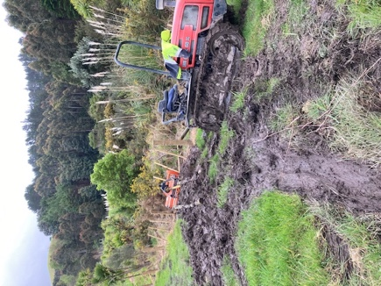 | 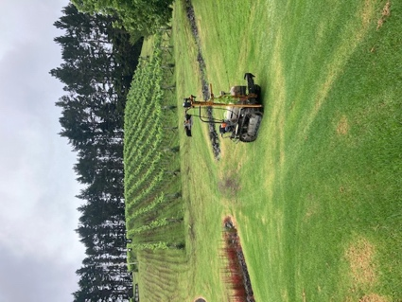
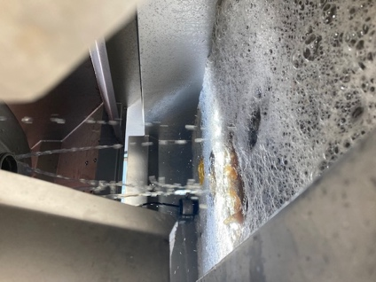

Harvest began in the mist…
February opened with a ten-day period of extreme humidity that had us whipping the Chardonnay off before it had any influence on the surprisingly good fruit condition.
Once the mist cleared, we were treated to some classic summer days that helped hold the condition of the other varieties until maturity. The middle of harvest was consumed with some long days picking Sauvignon Blanc and Syrah. Funnily enough the Cabernet Sauvignon which was the last to be harvested (16th March) and weathered the most was pin-up perfect, blackcurrant rich and concentrated. The only real constant of the season was the abundance of warm days and nights and this shows through in the wines which are immediately drinkable due to ample fruit sweetness and acid balance.

